**Basic Electrical Engineering**

**Laboratory (Branch – ALL)**

***List of Experiments***

***Cycle – 1:***

1. **Study and verification of Thevenin’s theorem.**
2. **Calculation of current, voltage, power and power factor in a series R-L-C circuit excited by 1-Ф AC supply.**
3. **Draw the B-H curve of a magnetic Specimen.**
4. **Study of Florescent lamp and improvement of power factor using Capacitor.**
5. **Connection and testing of Single Phase Energy meter using Unity power factor load.**

***Cycle – 2:***

1. **To perform the polarity test of a single-phase transformer.**
2. **Measurement of power consumed and power factor by a three-phase resistive load by Two-Wattmeter method.**
3. **Study and measurement of armature & field resistance of a D.C. machine.**
4. **To start a single phase permanent capacitor induction run motors.**
5. **To determine the efficiency & voltage regulation of a single-phase (1-φ) transformer by Direct loading.**

**EXPERIMENT NO:-1**

**Aim of the EXPERIMENT:-** Study and verification of Thevenin’s theorem.

**OBJECTIVE OF THE EXPERIMENT:-**

1. To study the basic operation of circuit.
2. To find the load current through Thevenin’s resistance and voltage.

**EQUIPMENTS REQUIRED:**

|  |  |  |  |
| --- | --- | --- | --- |
| **Sl.No** | **Instrument/Equipment** | **Specification** | **Quantity** |
| 1 | Single phase Variac | (0-270) Volts,15 Amps | 1 |
| 2 | Rheostat | 100Ω,5A  400Ω,2A | 3  1 |
| 3 | Voltmeter | (0-300) V, MI | 2 |
| 4 | Ammeter | (0-1)A,MI | 1 |
| 5 | Multimeter | Digital type | 1 |
| 6 | SPST Switch | 250V,5A | 1 |
| 7 | Connecting wire | 1.5mm2 | As per required |

**THEORY:-**

The Thevenin’s theorem states that the current in any passive element, RL in a linear bilateral network is the same as would be obtained if RL were supplied with a source voltage Vth in series with an equivalent resistance Rth; Vth being the open circuit voltage at the terminals from which RL has been removed and Rth being the resistance that would be measured at these terminals after all sources have been removed and each source has been replaced by its internal resistance.

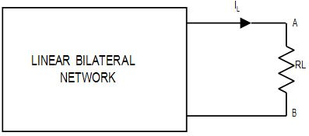

**CIRCUIT DIAGRAM:-**

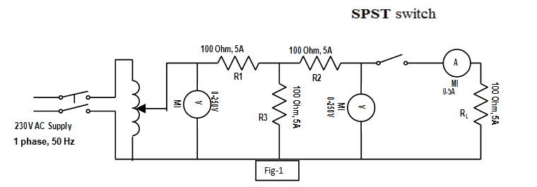

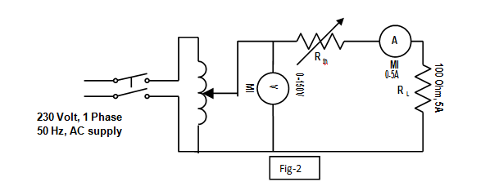

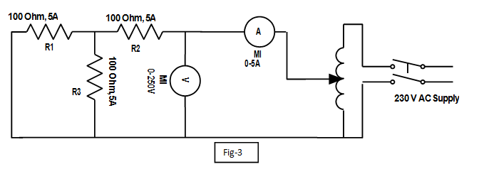

**PROCEDURE:**

**Load current measurement**

1. Connect the circuit as shown in the diagram.
2. Switch on the single phase a.c. supply.
3. Adjust the voltage to 100V and then switch on the SPST

Measure the current through the load resistance RL which is given by the ammeter. This can be recorded as IL(measured)

**Vth Measurement**

**1.** Open the SPST switch in circuit-1 and measure the voltage at the open circuit terminal.

**2**. The measured voltage gives Vth.

**Rth Calculation**

1. Connect the circuit as shown in circuit diagram-2.

2. Switch on in supply and vary the output voltage of the variac in steps.

3. At each step note the voltmeter and ammeter readings.

4. Calculate the output resistance of the circuit Ammeter-Voltmeter method.

**PRECAUTION:-**

1. All connections should be tight.
2. The circuit should be according to circuit diagram.
3. The power should be on when the circuit is checked completely.

**OBSERVATIONS TABLE:-**

**For calculate Rth**

|  |  |  |  |  |
| --- | --- | --- | --- | --- |
| **Sl. No.** | **V** | **I** | **R=V/I** | **Raverage** |
|  |  |  |  |  |
|  |  |  |  |  |
|  |  |  |  |  |
|  |  |  |  |  |

**IL(Measured)= Vth= Rth=**

**CALCULATION:-**

**IL(practical)=**

**CONCLUSION:-**

**QUESTIONS:-**

1. What do you mean by linear and bilateral network?
2. How to remove current and voltage source in a circuit?
3. What is the condition to find Rth?
4. What is the condition for finding Vth?

**EXPERIMENT NO:-2**

**Aim of the EXPERIMENT:-** Measurement of Current, Power and Power factor in R, RL, RC & RLC series circuit excited by single-phase AC supply.

**OBJECTIVE OF THE EXPERIMENT:-**

1. To find the current and power consumed by each circuit.
2. To calculate the power factor and observe the phasor relationship between voltage and current of each circuit.

**EQUIPMENTS REQUIRED:-**

|  |  |  |  |
| --- | --- | --- | --- |
| **Sl.No** | **Instrument/Equipment** | **Specification** | **Quantity** |
| 1 | Single phase variac | (0-270)V,15A | 1 |
| 2 | M.I. Ammeter | (0-1)A | 1 |
| 3 | M.I Voltmeter | (0-300 )V | 1 |
| 4 | Wattmeter(LPF) | 5A, 300V | 1 |
| 5 | R-L-C Trainer kit | (L=1.43H,C=5µF) | 1 |
| 6 | Lamp | 200W | 1 |
| 7 | Connectings wire | 1.5mm2 | As required |

**THEORY:-**

Consider an AC circuit containing resistance of R ohms, inductance of L henries and capacitance of C farads connected in series, as shown in circuit diagram. Let the current flowing through the circuit be of I ampere and supply frequency be f Hz.

1. Voltage drop across resistance VR =IR in phase with I.
2. Voltage drop across inductance VL= I(𝜔 L) leading I by 900
3. Voltage drop across capacitance, VC= I(𝜔 C) lagging behind I by 900

By applying KVL in the above RLC series circuit

*V = VR* + *VL* + *VC*

= *IR+ IX L* +*IXC*

= *I* (*R +* *XL* + *XC* )

In the series RLC circuit, if

Case (1): *XL* > *XC* current lags the voltage (Fig. 1)

Case (2): *XL* < *XC*current leads the voltage (Fig. 2)

Case (3): *XL* = *XC* current and voltage are in phase (Fig. 3)

**Phasor Diagrams are:**

#### *C:\Users\Silicon\Desktop\Untitled.jpg*

**CIRCUIT DIAGRAM:-**

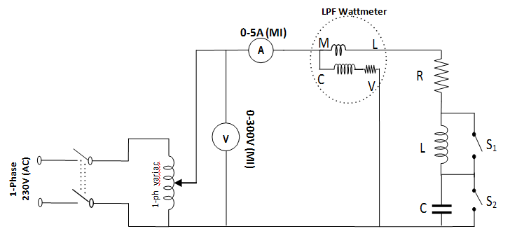

**PROCEDURE:-**

1. Connect the circuit as per the circuit diagram.
2. Close SPST switch S1& S2 and close the main switch.
3. Take the readings of all the meters. This will give the voltage, current and power for a R-circuit.

4. Steps to Open switch S1& S2 in get RL & RC circuit parameters respectively.

5. Similarly, open switch S1& S2 simultaneously to get the parameters for series RLC circuit.

6. Compare the parameters two different combination of R, L & C.

7. The power supply should be switched OFF.

**PRECAUTION:-**

1. The connections should be proper as per the circuit diagram.
2. After verifying the circuit connection thoroughly, the supply should be switched ON.
3. Reading of the meter should be taken correctly.

**OBSERVATIONS:-**

|  |  |  |  |  |  |
| --- | --- | --- | --- | --- | --- |
| **Type of circuit** | **Supply voltage**  **(Volts)** | **Current**  **(Amps)** | **Power**  **(watts)** | **Power factor**  **(cos**Ø**)** | **Remarks** |
| **R** |  |  |  |  |  |
| **R-L** |  |  |  |  |  |
| **R-C** |  |  |  |  |  |
| **R-L-C** |  |  |  |  |  |

**CALCULATION:-**

#### For RLC circuit:

*XL* = 2*πfL*

*Xc* = 1/2*πfc*

Z=

**CONCLUSION:-**

**QUESTIONS:-**

1. What do you mean by inductive load?
2. Define power factor.
3. State all types of electrical loads.
4. Why a current lags/leads a voltage in a circuit?
5. State the conditions where the apparent power becomes equal to reactive power

**EXPERIMENT NO:-3**

**Aim of the EXPERIMENT:-** Draw the B-H curve of a magnetic Specimen.

**OBJECTIVE OF THE EXPERIMENT:-**

1. To know about the magnetic saturation.
2. Find the residual magnetism of the magnetic material.

**EQUIPMENTS REQUIRED:-**

|  |  |  |  |
| --- | --- | --- | --- |
| **Sl.No** | **Instrument/Equipment** | **Specification** | **Quantity** |
| 1 | Single phase transformer | 1KVA,110/230V | 1 |
| 2 | M.I. Ammeter | (0-200)mA | 1 |
| 3 | Multimeter | Digital type | 1 |
| 4 | Single phase variac | (0-270)V,5A | 1 |
| 5 | Connecting wire | 1.5mm2 | As required |

**THEORY:-**

Magnetic Hysteresis means the lagging of magnetization (or) induction flux density (B) behind the Magnetizing force (H). It may be defined as that quality of a magnitude substance due to which energy is dissipated in it on the reversal of its magnetism.

When an un magnetized bar of iron is magnetized by placing it with in the field of a solenoid, the Magnetising by placing it within the field of a solenoid, the Magnetising field H (= NI/L) is produced by the solenoid called the magnetising force. The value of H can be increased or decreased by increasing or decreasing current through the coil. That is H ∞ I1. According to faradays law of electromagnetic induction, V2 = N (dø/dt) = N2BAs/RC (Flux = BAs, Time constant = RC and N2 = Secondary turns).

By varying magnetizing force (H) and noting the corresponding values of flux density ‘B’ we have a loop as follows which is known as Hysteresis loop.

The relationship between B&H is as follows,

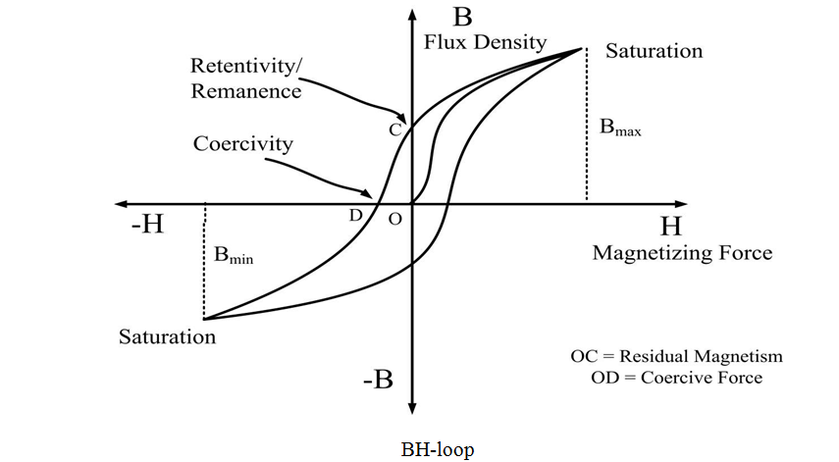

**CIRCUIT DIAGRAM:-**

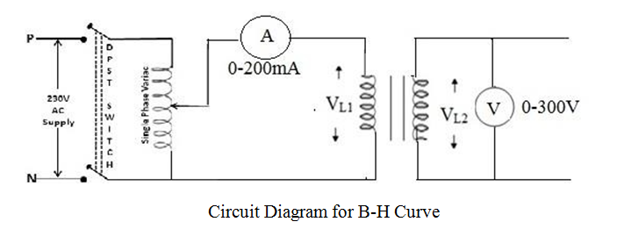

**Circuit Diagram for B-H Curve**

**PROCEDURE:-**

1. Make connection as per the circuit diagram.

2. Switch on the main supply with Variac in zero position.

3. Vary the primary current of the transformer in increasing order from 0 mA to 120mA with difference and take the corresponding reading of primary current (I1) and secondary voltage (V2).

4. Switch OFF the power supply.

5. Plot the graph between I1 & V2.

**PRECAUTION:-**

1. The connections should be proper as per the circuit diagram.
2. After verifying the circuit connection thoroughly, the supply should be switched ON.
3. Reading of the meter should be taken correctly.

**OBSERVATIONS:-**

**For increasing primary current (I1)**

|  |  |  |
| --- | --- | --- |
| **SI.NO** | **Primary current(I1)** | **Secondary voltage(V2)** |
|  |  |  |
|  |  |  |
|  |  |  |
|  |  |  |
|  |  |  |
|  |  |  |
|  |  |  |
|  |  |  |
|  |  |  |

**CONCLUSION:-**

**DISSCUSION:-**

1. Why the middle portion of B-H curve is linear for ferromagnetic material?
2. Is slope of B-H curve varies for ferromagnetic material?
3. Can we ignore B-H loop, Justify?
4. Can frequency of ac supply affect B-H loop, Justify.

**EXPERIMENT NO-4**

**Aim of the EXPERIMENT:-** Study of Fluorescent lamp and improvement of power factor using capacitor.

**OBJECTIVE OF THE EXPERIMENT:-**

1. To find pick up and cut off voltage of fluorescent lamp.
2. To calculate power and power factor of the given lamp.
3. To measure improved power factor using a capacitor.

**EQUIPMENTS REQUIRED:-**

|  |  |  |  |
| --- | --- | --- | --- |
| **SI.NO** | **EQUIPMENT** | **SPECIFICATION** | **QUANTITY** |
|  | Voltmeter | MI type (0-300)V | 1 |
|  | Ammeter | MI type (0-1)A | 1 |
|  | Wattmeter (LPF) | 5A,300V | 1 |
|  | Single phase variac | (0-270)V,15A | 1 |
|  | Fluorescent light trainer kit | 250V,5A,40W | 1 |
|  | Capacitor | 2.5µF | 2 |
|  | Connecting wires | 1.5 mm2 | As per required |

**THEORY:-**

#### Fluorescent lamp:

The fluorescent tube consists of a glass tube. The tube contains argon gas at low pressure and one or two drops of mercury and inside surface of the tube is coated with a thin layer of fluorescent material in the form of powder. The coating material used depends upon the color effect desired may consists of zinc silicate, cadmium silicate or calcium tungsten. These organic chemicals are known as phosphorus which transforms short wave invisible radiation into visible light. A Choke is connected in series with the tube which acts as ballast in running condition and provides a high voltage impulse or surge for instantaneous time for starting the tube light. A starter is connected between two electrodes as shown in fig, which has a bimetallic strip. The bimetallic strip makes the path between two electrodes closed at starting and makes it open under normal operating condition.

#### Power Factor and its improvement:

Power factor is the ratio of the actual power drawn by the load (Watt) to the apparent power (VA) drawn by the load. Power factor improvement means for a particular load actual power drawn is ideally remains constant but the apparent power decreases. Keeping the supply voltage across the load constant at its rated value, the current drawn from the supply will decrease. If the p.f is unity then apparent power drawn is equal to the actual power.

* 1. If the original load is Resistive + inductive (For power factor improvement, use a parallel capacitor as per requirement)

2. If the original load is Resistive + Capacitive (For power factor improvement, use a inductor in parallel as per requirement.

**CIRCUIT DIAGRAM:-**

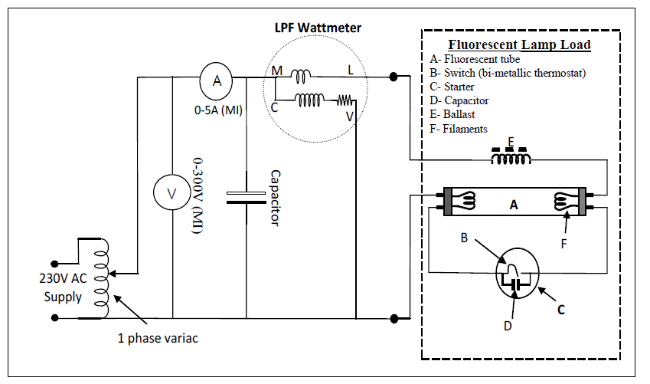

**PROCEDURE:-**

1. Connect as per circuit diagram keeping the variac at minimum position.
2. Switch ON the supply.

3. Increase the voltage gradually. The voltage at which the fluorescent light just glows is

Known as pick-up voltage. Note down the meter readings.

4. Further increase the voltage up to a level (230V) where the light glows brightly

5. Now, decrease the voltage gradually. The voltage at which the light darkens is known as cut-off voltage.

6. Take the meter readings at each step

7. Switch off the supply

**With capacitor:-**

1. Repeat the above steps by connecting a capacitor in parallel with the load

2. Change the capacitor value to observe its effect on power factor

3. Take the meter readings by changing the capacitor value

**PRECAUTION:-**

1. The connections should be proper as per the circuit diagram.

2. After verifying the circuit connection thoroughly, the supply should be switched ON.

3. Reading of the meter should be taken correctly.

**OBSERVATIONS:-**

**Pick-up voltage= Cut-off voltage=**

**Table – 1: Without capacitor:**

|  |  |  |  |  |  |  |
| --- | --- | --- | --- | --- | --- | --- |
| **Sl.**  **No.** | **Supply**  **voltage (V)** | **Circuit**  **current (I)**  **( In Amps)** | **Actual Power**  **consumed (P)**  **(In watts)** | **Apparent**  **Power (S)**  **(In VA)** | **Cos** φ  **(P/S)** | **Reactive Power**  **(QL = VI Sin** φ**) (In VAR** |
|  |  |  |  |  |  |  |

**Table – 2: With capacitor**

|  |  |  |  |  |  |  |
| --- | --- | --- | --- | --- | --- | --- |
| **Sl.**  **No.** | **Supply**  **voltage (V)** | **Circuit**  **current (I1)**  **( In Amps)** | **Actual Power**  **consumed (P)**  **(In watts)** | **Apparent**  **Power (S1)**  **(In VA)** | **Cos** φ  **(P/S1)** | **Reactive Power**  **(Q1 = VI1 Sin** φ**) (In VAR)** |
|  |  |  |  |  |  |  |

**CALCULATIONS:**

S = Vrms × Irms (VA) P = Vrms × Irms cosφ (Watt) QL = Vrms × Irms sinφ (VAR)

Power factor, cosφ=P/S Power factor angle, φ = cos-1(P/S)

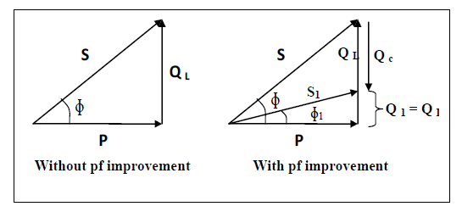

**CONCLUSION:-**

**DISSCUSION:-**

1. Working principle of fluorescent lamp.
2. What is power factor?
3. Why does Power Factor Matter?
4. How to improve Power Factor?
5. What are the benefits of Power Factor correction?
6. What are Signs of a Low Power Factor?
7. What are the causes of a Low Power Factor?

**EXPERIMENT NO-05**

**Aim of the EXPERIMENT:-** Connection and testing of single phase energy meter (using unity power factor load).

**OBJECTIVE OF THE EXPERIMENT:-**

1. Find the error of the energy meter.
2. Know about the meter constant of the energy meter.

**EQUIPMENTS REQUIRED:-**

|  |  |  |  |
| --- | --- | --- | --- |
| **Sl. No** | **Instrument/Equipment** | **Specification** | **Quantity** |
| 1 | 1-φ Energy meter | 5/20A,250V,600RPU | 1 |
| 2 | M.I Ammeter | (0-5) A | 1 |
| 3 | M.I Voltmeter | (0-300) V | 1 |
| 4 | Stopwatch | Digital type | 1 |
| 5 | Lamp load | 3KW | 1 |
| 6 | Connecting Wires | 1.5mm2, Cu wire | As required |

**THEORY:-**

Energy meter is an instrument, which measure the electrical energy**.** It is an integrating type instruments also known as watt hour meter. A single phase induction type energy meter consists of two laminated electromagnet one is series known as current coil (**CC**) and other is shunt known as pressure coil short circuited copper bands on lower part of central limb of shunt magnet are called power factor compensator (**PFC**).A thin aluminum disc mounted on a spindle is placed in the air gap between the magnets. Eddy currents are induced on the disc due to fluxes because the disc to move and the registering system having counting mechanism records the revolutions of the disc. The counter is calibrated to indicate the energy consumed directly in kilowatt-hours (**Kwh**).

**CIRCUIT DIAGRAM:-** 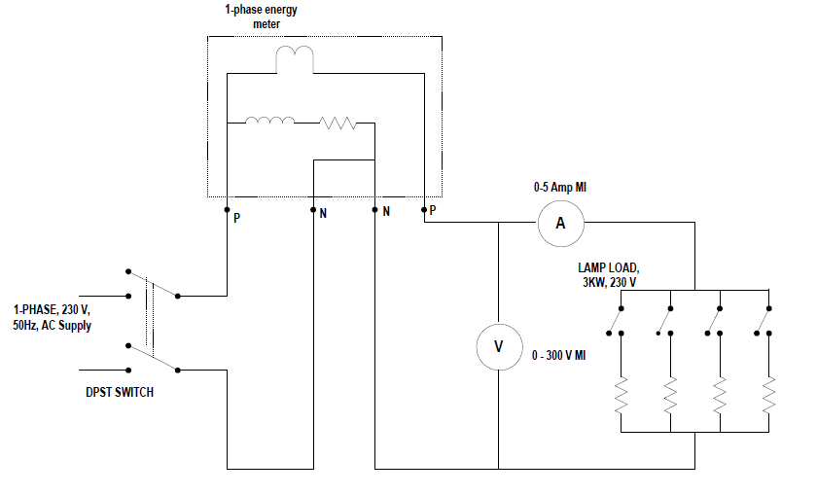

**PROCEDURE:-**

* 1. Connect the circuit as per the circuit diagram.
  2. Before switching ON the supply ensures that the lamp load switches are open..
  3. Note down the initial reading of the meter.
  4. Set the desired lamp load by selecting a suitable combination of switches.
  5. Switch ON the supply and wait for the energy meter disc to come in the front of the black strip.

6. At this moment start the stop watch. Note down the voltmeter and ammeter readings.

7. Measure the time taken to complete 10 revolutions by the help of stop watch. Switch off the

Supply.

8. By adjusting the loading take 8 to 10 sets of readings covering the full current range of

The energy meter and tabulate the observation table.

**PRECAUTION:-**

1. The connections should be proper as per the circuit diagram.
2. After verifying the circuit connection thoroughly, the supply should be switched ON.
3. Reading of the meter should be taken correctly.

**OBSERVATIONS:-**

|  |  |  |  |  |  |  |
| --- | --- | --- | --- | --- | --- | --- |
| **Sl. No** | **Supply**  **Voltage(V)**  **(Volts)** | **Circuit**  **Current(I)**  **(Amps)** | **Time(t) for10**  **revolutions**  **(Sec) (t)** | **Actual**  **energy**  **(VIt) khw** | **Recorded**  **Energy**  **(kwh)** | **% Error** |
|  |  |  |  |  |  |  |
|  |  |  |  |  |  |  |
|  |  |  |  |  |  |  |

**CALCULATION:-**

For observation no. : …………

Power consumed by the load = VI watt.

Time taken to complete 10 revolutions = t secs.

Actual energy consumed = Vit/(1000×3600) kwh

Energy read by the energy meter = No. of revolutions/Meter constant

% Error = [(Actual energy-Measured energy) /Actual Energy] ×100

**CONCLUSION:-**

**DISSCUSION:-**

1. What is the meter constant of the energy meter?
2. Why there is a hole in the aluminum disc?
3. How many coils in a energy meter?
4. What is the unit of electrical energy?
5. What is the effect of different types of load in the energy meter?
6. What is the difference between energy meter and wattmeter?